Lab 11.1

Refer to Chapter 9: Getting Started with JavaScript

Add a screenshot of the source code of the **tny_clock.html file** after completing Step 3 on page HTML 688

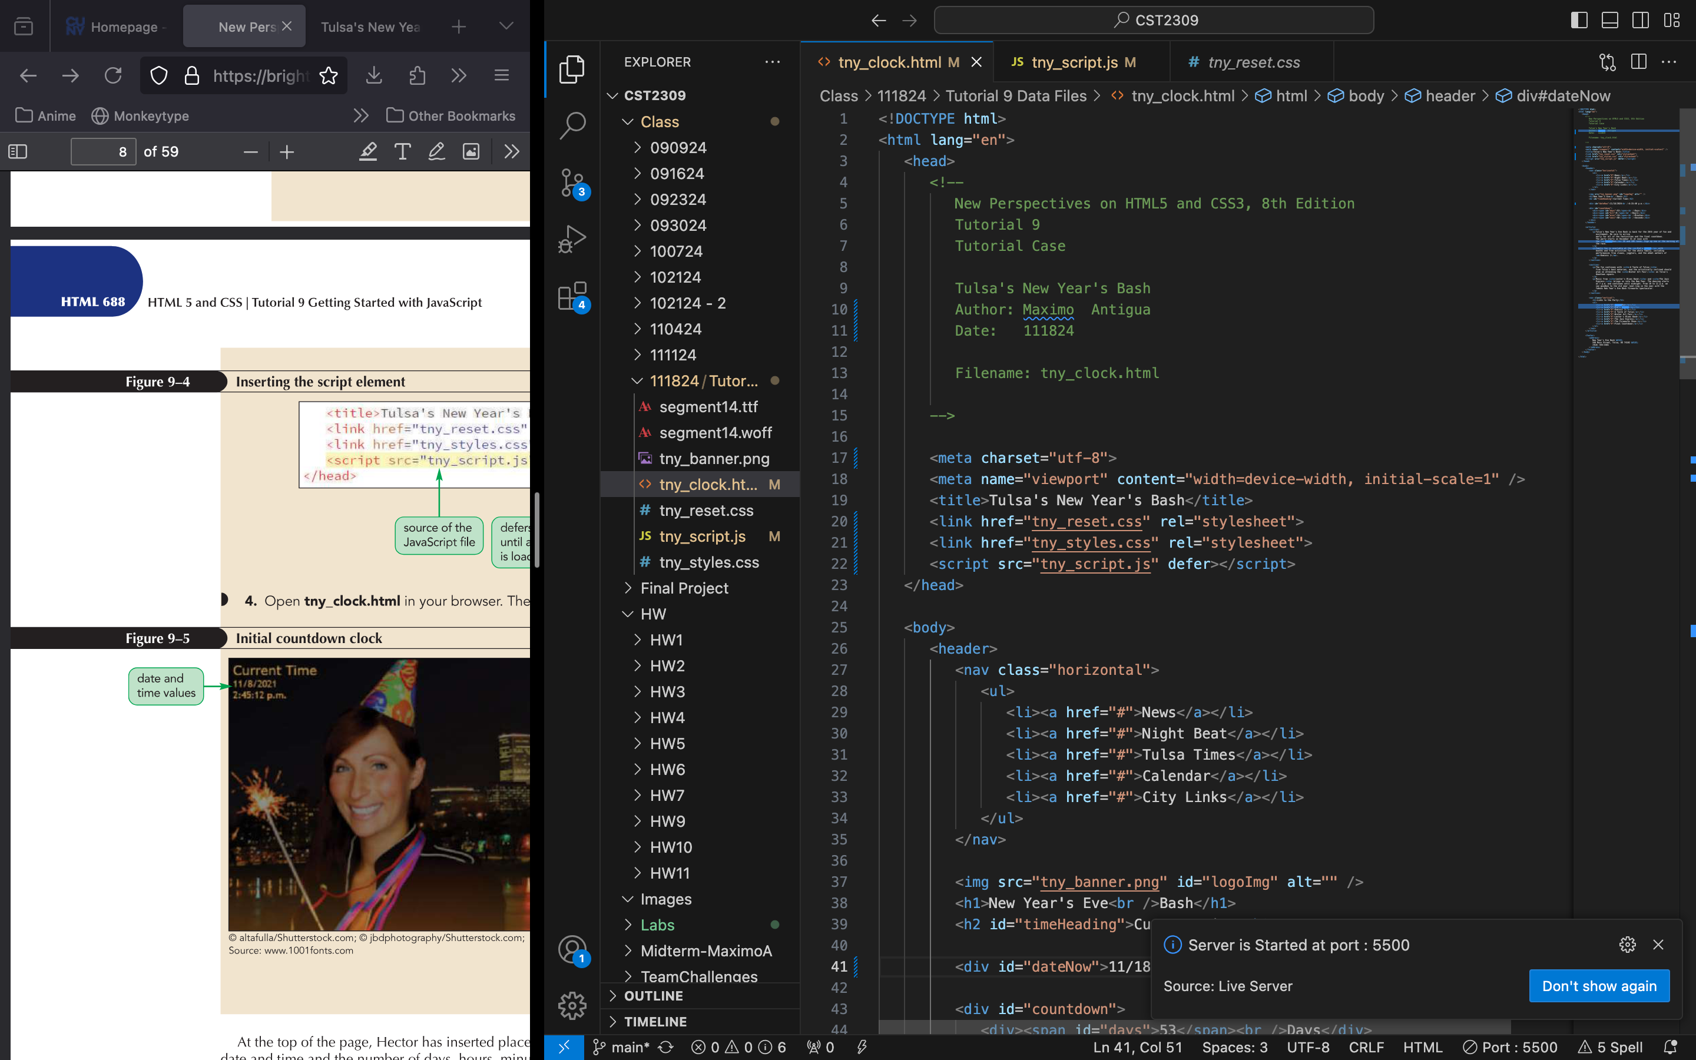

Add a screenshot of the **tny_clock.html file** displayed in your web browser after completing Step 4 on page HTML 688

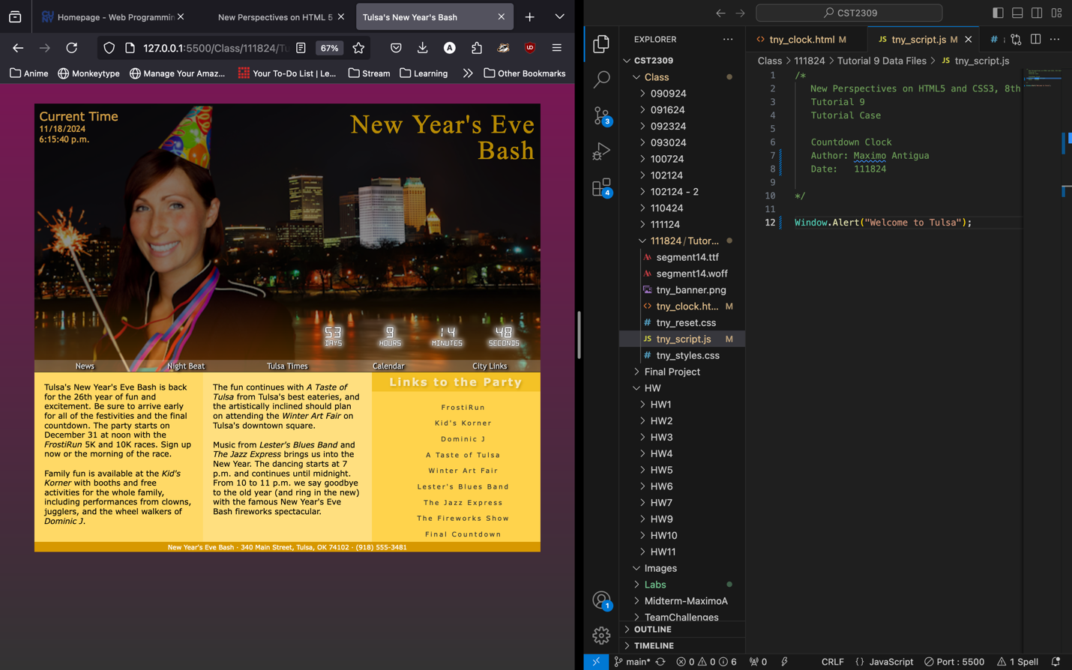

Add a screenshot of the **tny_script.js file** after completing Step 1 on page HTML 690



Add a screenshot of the **tny_clock.html file** displayed in your web browser after completing Step 2 on page HTML 691



Answer the following questions:

1. Describe the three types of program errors.

Run-time error, logical error, and load-timer error.

1. What is the error in the following code and what type of error is it?

document.writ("Hello World");

TypeError: document.writ is not a function, and this is a logical error.

1. What is the error in the following code and what type of error is it?

let firstValue = 10;

let secondValue = 20;

let result = firstvalue + secondValue;

firstValue being misspelled, and this is a logical error.

1. If the browser console reports a single syntax error, does that mean there is only one syntax error in the code? Explain your answer

No, the displayed error is only for the line where the element is first applied. If any other place it is used is called (or interacted in the case of events), we will see more errors on our Debugging console.

1. Many developers advocate that JavaScript be run in strict mode. What is strict mode and how is it implemented?

Strict mode makes all lapses in syntax to load time and run-time errors. This can be implemented by adding this to the first line of the HTML: use strict;